

Practices for Secure Software Report

Table of Contents
Practices for Secure Software Report 1
Document Revision History 3
Client 3
Instructions 3
Developer 4
1. Algorithm Cipher 4
2. Certificate Generation 4
3. Deploy Cipher 6
4. Secure Communications 6
5. Secondary Testing 6
6. Functional Testing 8
7. Summary 9
8. Industry Standard Best Practices 10

Document Revision History

Version | Date | Author | Comments
1.0 | October 12, 2026 | Jesse Carles | Initial secure application refactor, tests, and dependency assessment

Client



Instructions

Submit this completed practices for secure software report. Replace the bracketed text with the relevant information. You must document your process for writing secure communications and refactoring code that complies with software security testing protocols.

- Respond to the steps outlined below and include your findings.
- Respond using your own words. You may also choose to include images or supporting materials. If you include them, make certain to insert them in all the relevant locations in the document.
- Refer to the Project Two Guidelines and Rubric for more detailed instructions about each section of the template.

Developer
Jesse Carles

1. Algorithm Cipher
I recommend AES-256 in Galois/Counter Mode (AES-GCM) for encryption of confidential financial data and TLS 1.3 (or TLS 1.2 where necessary) for data in transit. AES is a symmetric block cipher with a 128-bit block size; a 256-bit key provides a high security margin. GCM adds authenticated encryption so altered ciphertext is rejected, and it requires a fresh, unique nonce for every encryption operation under the same key. Nonces must never be reused with the same AES-GCM key.
Encryption and hashing solve different problems. The implemented SHA-256 checksum uses a one-way hash rather than an encryption cipher: its 256-bit output (64 hexadecimal characters) detects unintended changes when compared with a trusted expected value. SHA-256 does not provide confidentiality, and an unkeyed digest alone cannot authenticate a malicious sender who can replace both the message and checksum. In production I would use TLS with certificate validation for transport authentication and, where independent origin authentication is necessary, HMAC-SHA-256 or a digital signature.
TLS combines asymmetric techniques for authentication and key agreement with efficient symmetric session encryption. A self-signed RSA certificate with a 3,072-bit key was generated for local development; modern TLS typically negotiates ephemeral session secrets and symmetric AEAD ciphers. SecureRandom-class entropy is essential for generating private keys and nonces. Historically, DES became obsolete because of its short effective key; 3DES is deprecated; AES replaced those older symmetric standards. SHA-1 is unsuitable for collision-sensitive security. AES, SHA-256, and modern TLS remain well-established technologies, with algorithms and configuration subject to continuing updates.

2. Certificate Generation
Using Java Keytool through the Eclipse terminal, I generated a PKCS#12 keystore named artemis-keystore.p12 containing an RSA 3,072-bit key pair and a self-signed certificate signed with SHA256withRSA. The certificate identified CN=localhost and included Subject Alternative Names for localhost and 127.0.0.1. I then exported the public certificate to artemis.cer and used keytool -printcert to inspect it. Both artifacts appear in src/main/resources of the submitted project.
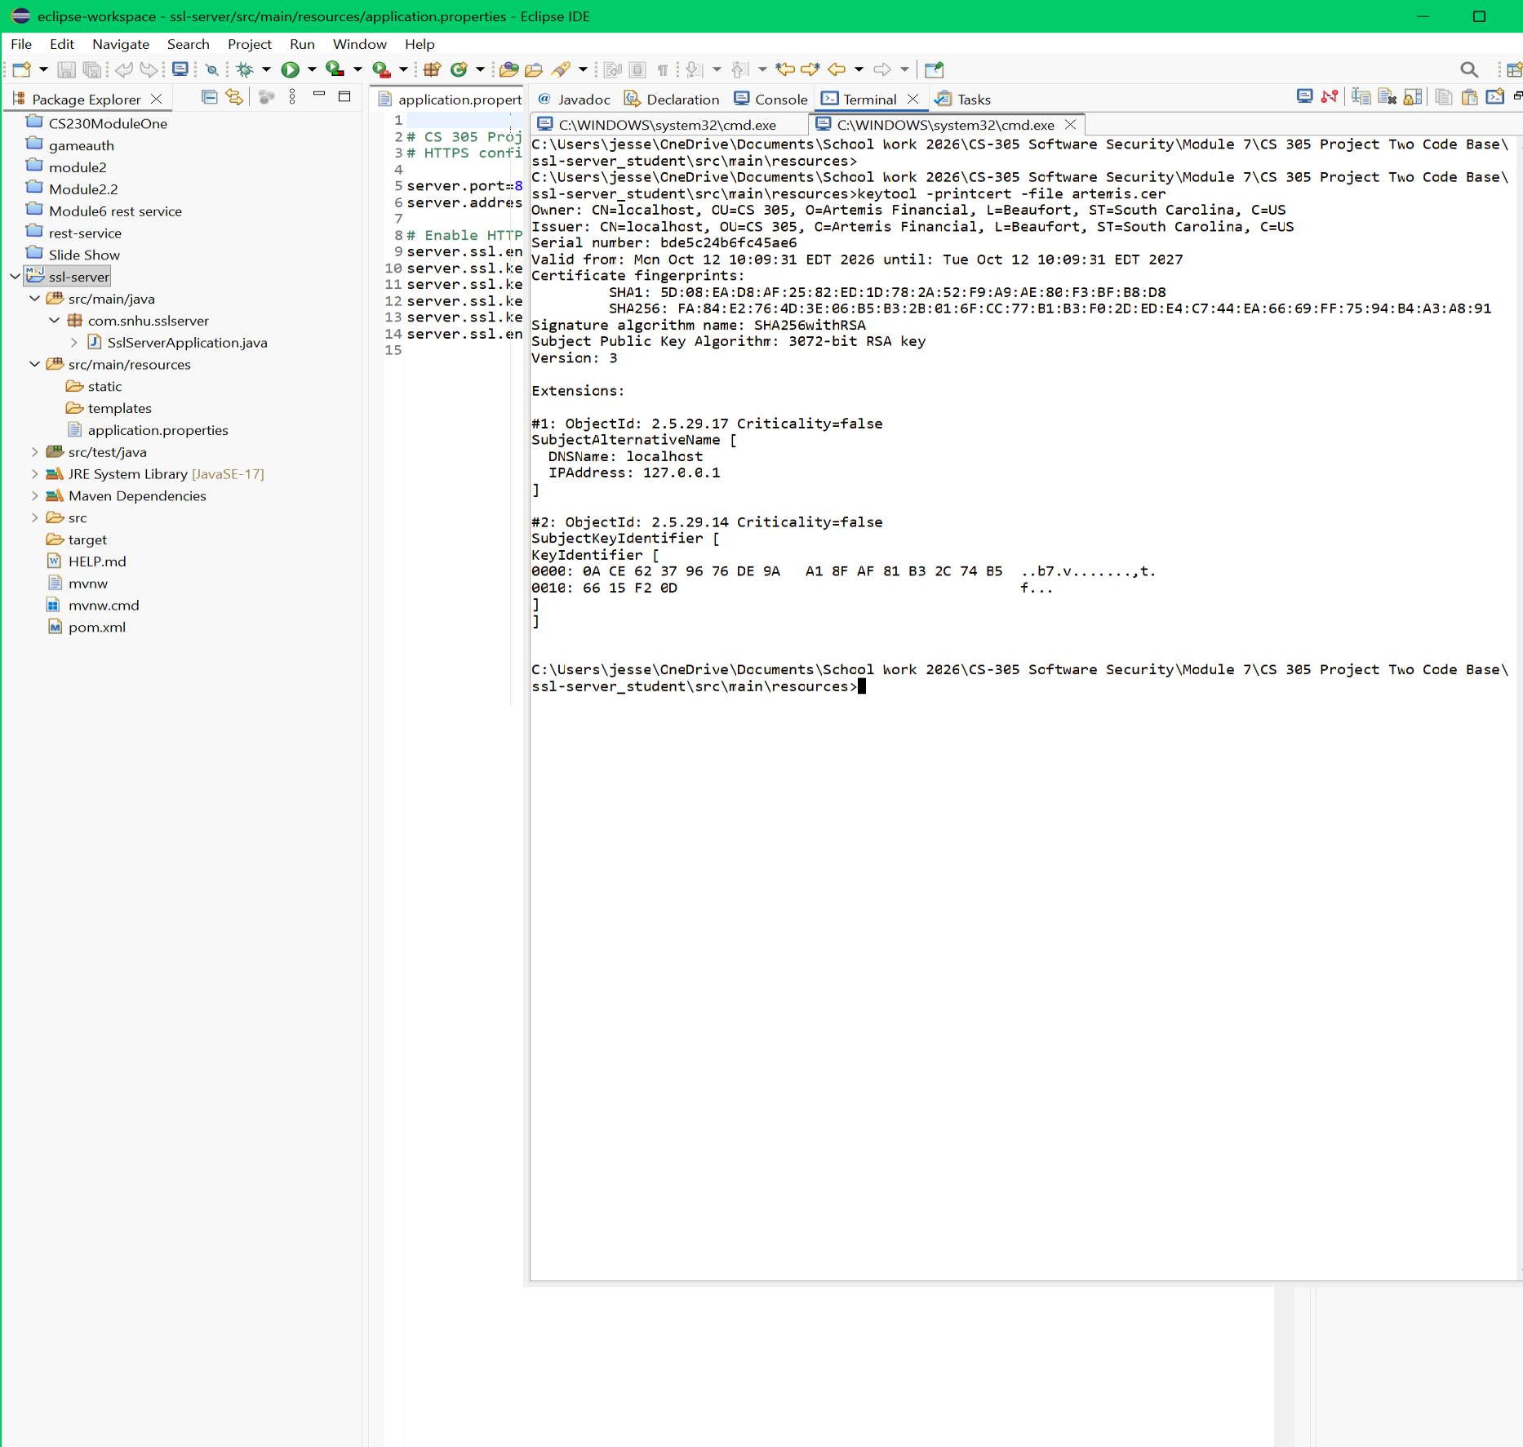
The self-signed certificate supports local HTTPS testing; it does not establish public trust. A publicly deployed financial service must use a valid certificate from a trusted CA with appropriate domain verification, key handling, and renewal procedures. The private key in the PKCS#12 file is for coursework only and should never be published as a production key.

3. Deploy Cipher
I refactored SslServerApplication.java to compute SHA-256 over UTF-8 encoded data using MessageDigest.getInstance("SHA-256"), return lowercase hexadecimal with HexFormat, and compare digest bytes using MessageDigest.isEqual. Verification rejects null inputs and hashes that do not match a 64-character hexadecimal format. The demonstration data contains my name and a project-specific string. The /hash endpoint displays the computed digest, successful comparison, and confirmation that modified data is not accepted.
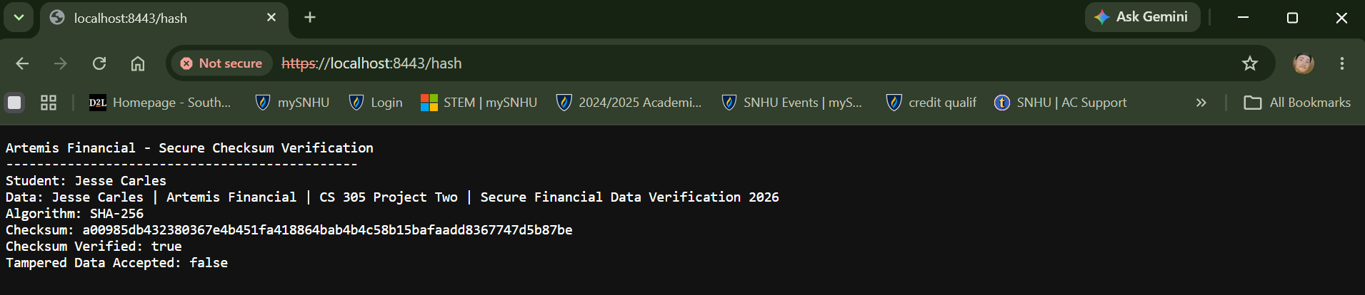
The application also exposes /hash/verify?data=...&checksum=... for checking a supplied value. This demonstrates detection of changed content relative to the presented checksum, but it is not itself proof of sender authenticity.

4. Secure Communications
The application.properties file configures server.port=8443, server.address=127.0.0.1, server.ssl.enabled=true, PKCS12 keystore artemis-keystore.p12, key alias artemis, and TLSv1.3/TLSv1.2. The keystore password is supplied through the SSL_KEYSTORE_PASSWORD environment variable rather than hardcoded in source. With Spring Boot running, Chrome successfully loaded https://localhost:8443/hash and displayed the checksum response over HTTPS.

5. Secondary Testing
I ran OWASP Dependency-Check Maven plugin version 12.1.0 against the application dependencies. The first successful scan flagged 7 vulnerable dependencies and 143 vulnerability entries among 34 scanned dependencies. I then upgraded the Spring Boot parent from 3.5.6 to 3.5.16 without changing the functional checksum implementation, reran automated tests, and executed the scan again. The subsequent report, generated October 12, 2026 at 11:02 a.m. ET, recorded 34 scanned dependencies (19 unique), 5 vulnerable dependencies, 61 findings and 0 suppressed findings. This represents 82 fewer reported findings (approximately 57.3%).
Scan metric | Before | After
Spring Boot parent | 3.5.6 | 3.5.16
Scanned dependencies | 34 | 34 (19 unique)
Flagged dependencies | 7 | 5
Reported findings | 143 | 61
Suppressed findings | 0 | 0

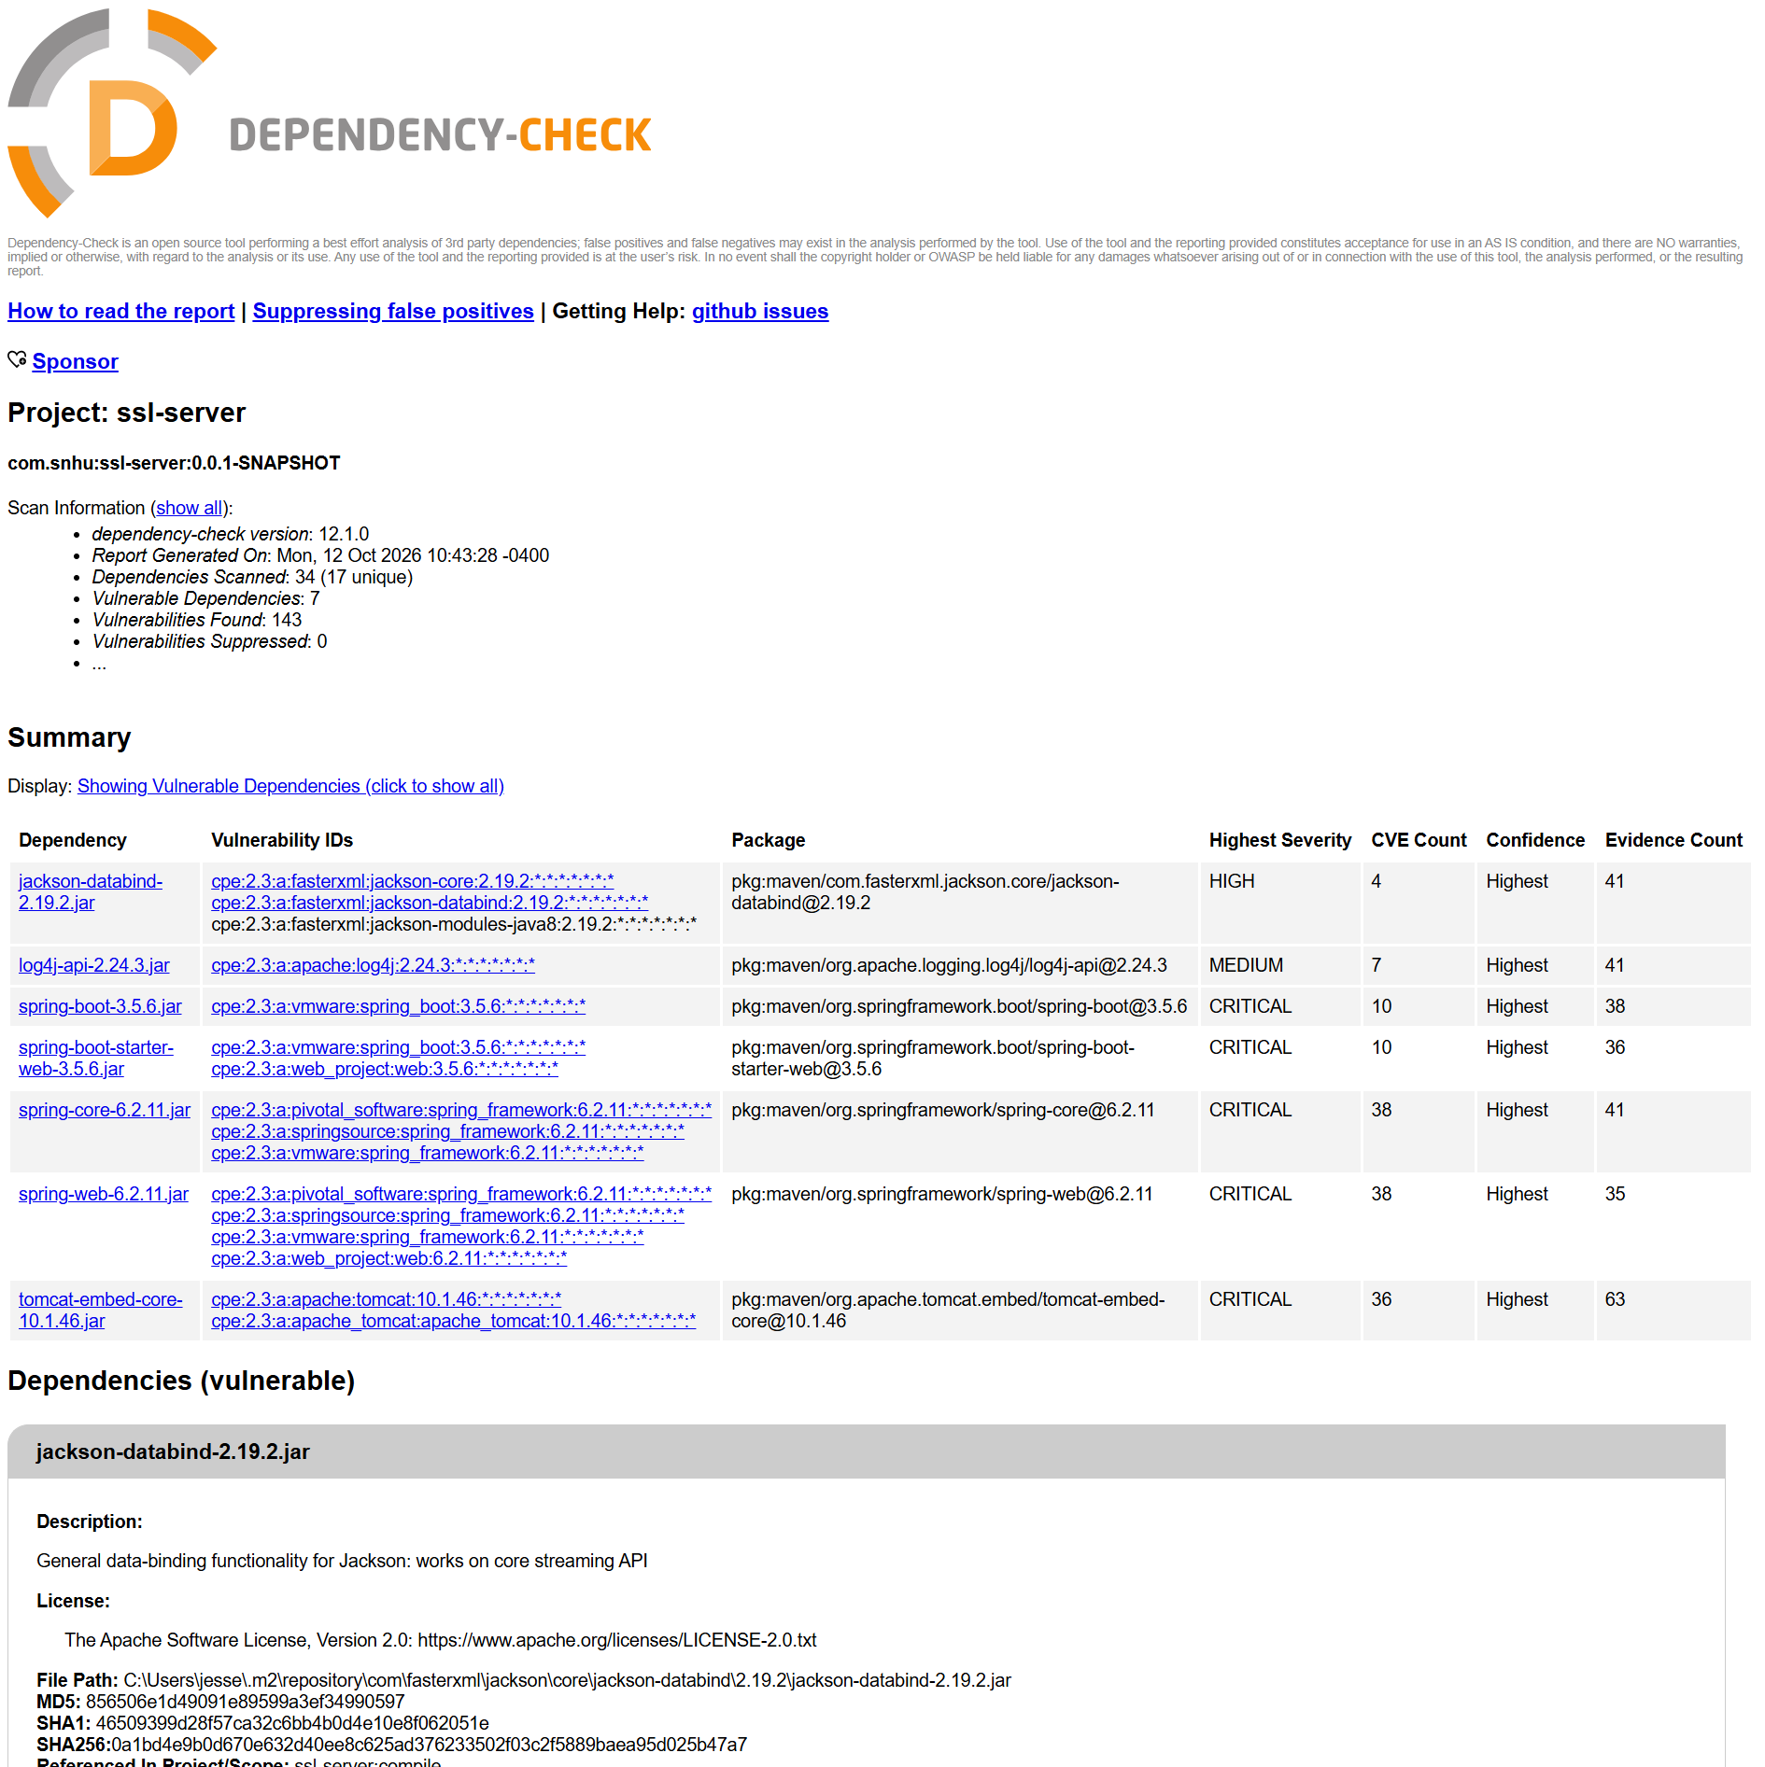
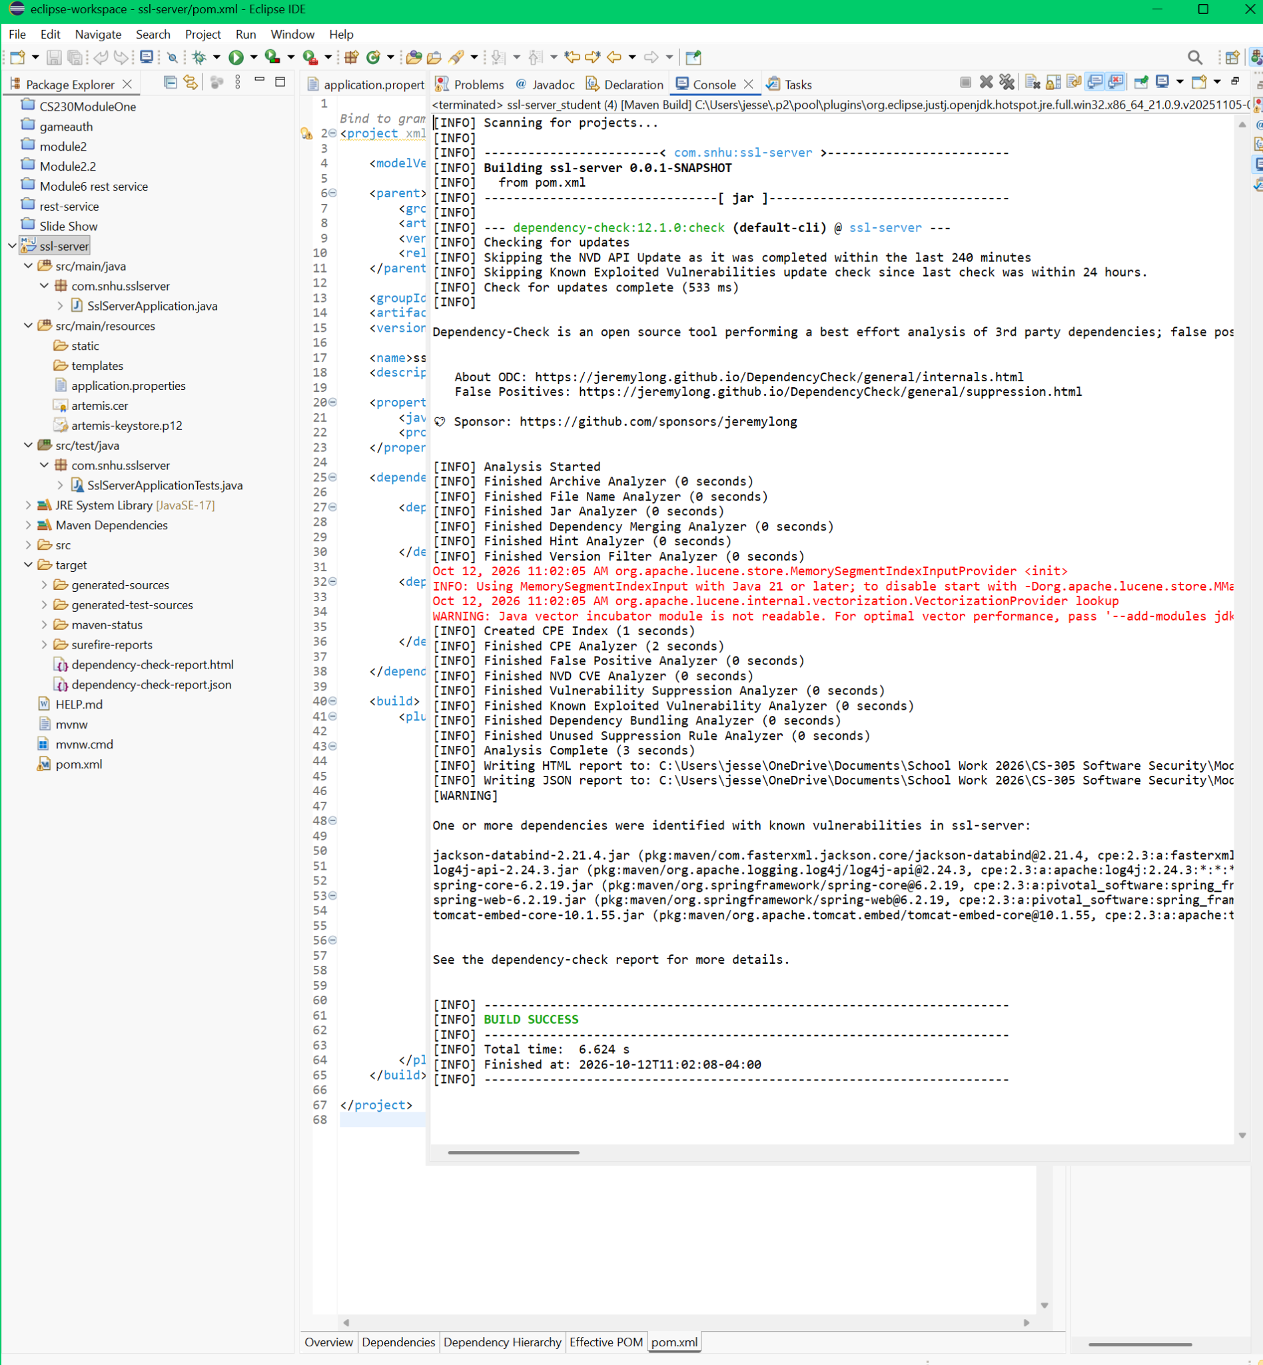

6. Functional Testing
Manual source review covered syntax, logic, and security: the SHA-256 algorithm name and imports, deterministic UTF-8 byte conversion, digest formatting, null and malformed-input rejection, a 2,048-character input bound on /hash/verify, and timing-resistant byte-array comparison. I reviewed application configuration for HTTPS port 8443, certificate selection, environment-variable password handling, and locally bound interface. I also tested correct and deliberately incorrect checksums in the browser.
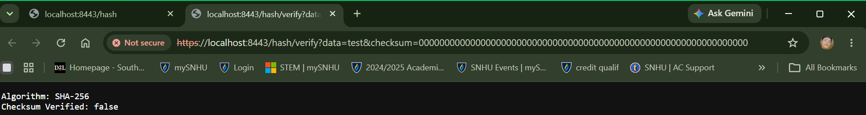
The revised Maven test run passed all nine JUnit tests, with zero failures, zero errors and zero skipped. Tests cover Spring context loading, correct SHA-256 format, deterministic output, valid checksum acceptance, modified-data rejection, invalid checksum rejection, null handling, and the published SHA-256 test vector for “abc”. The reported Java/Mockito agent warnings did not cause test failures.
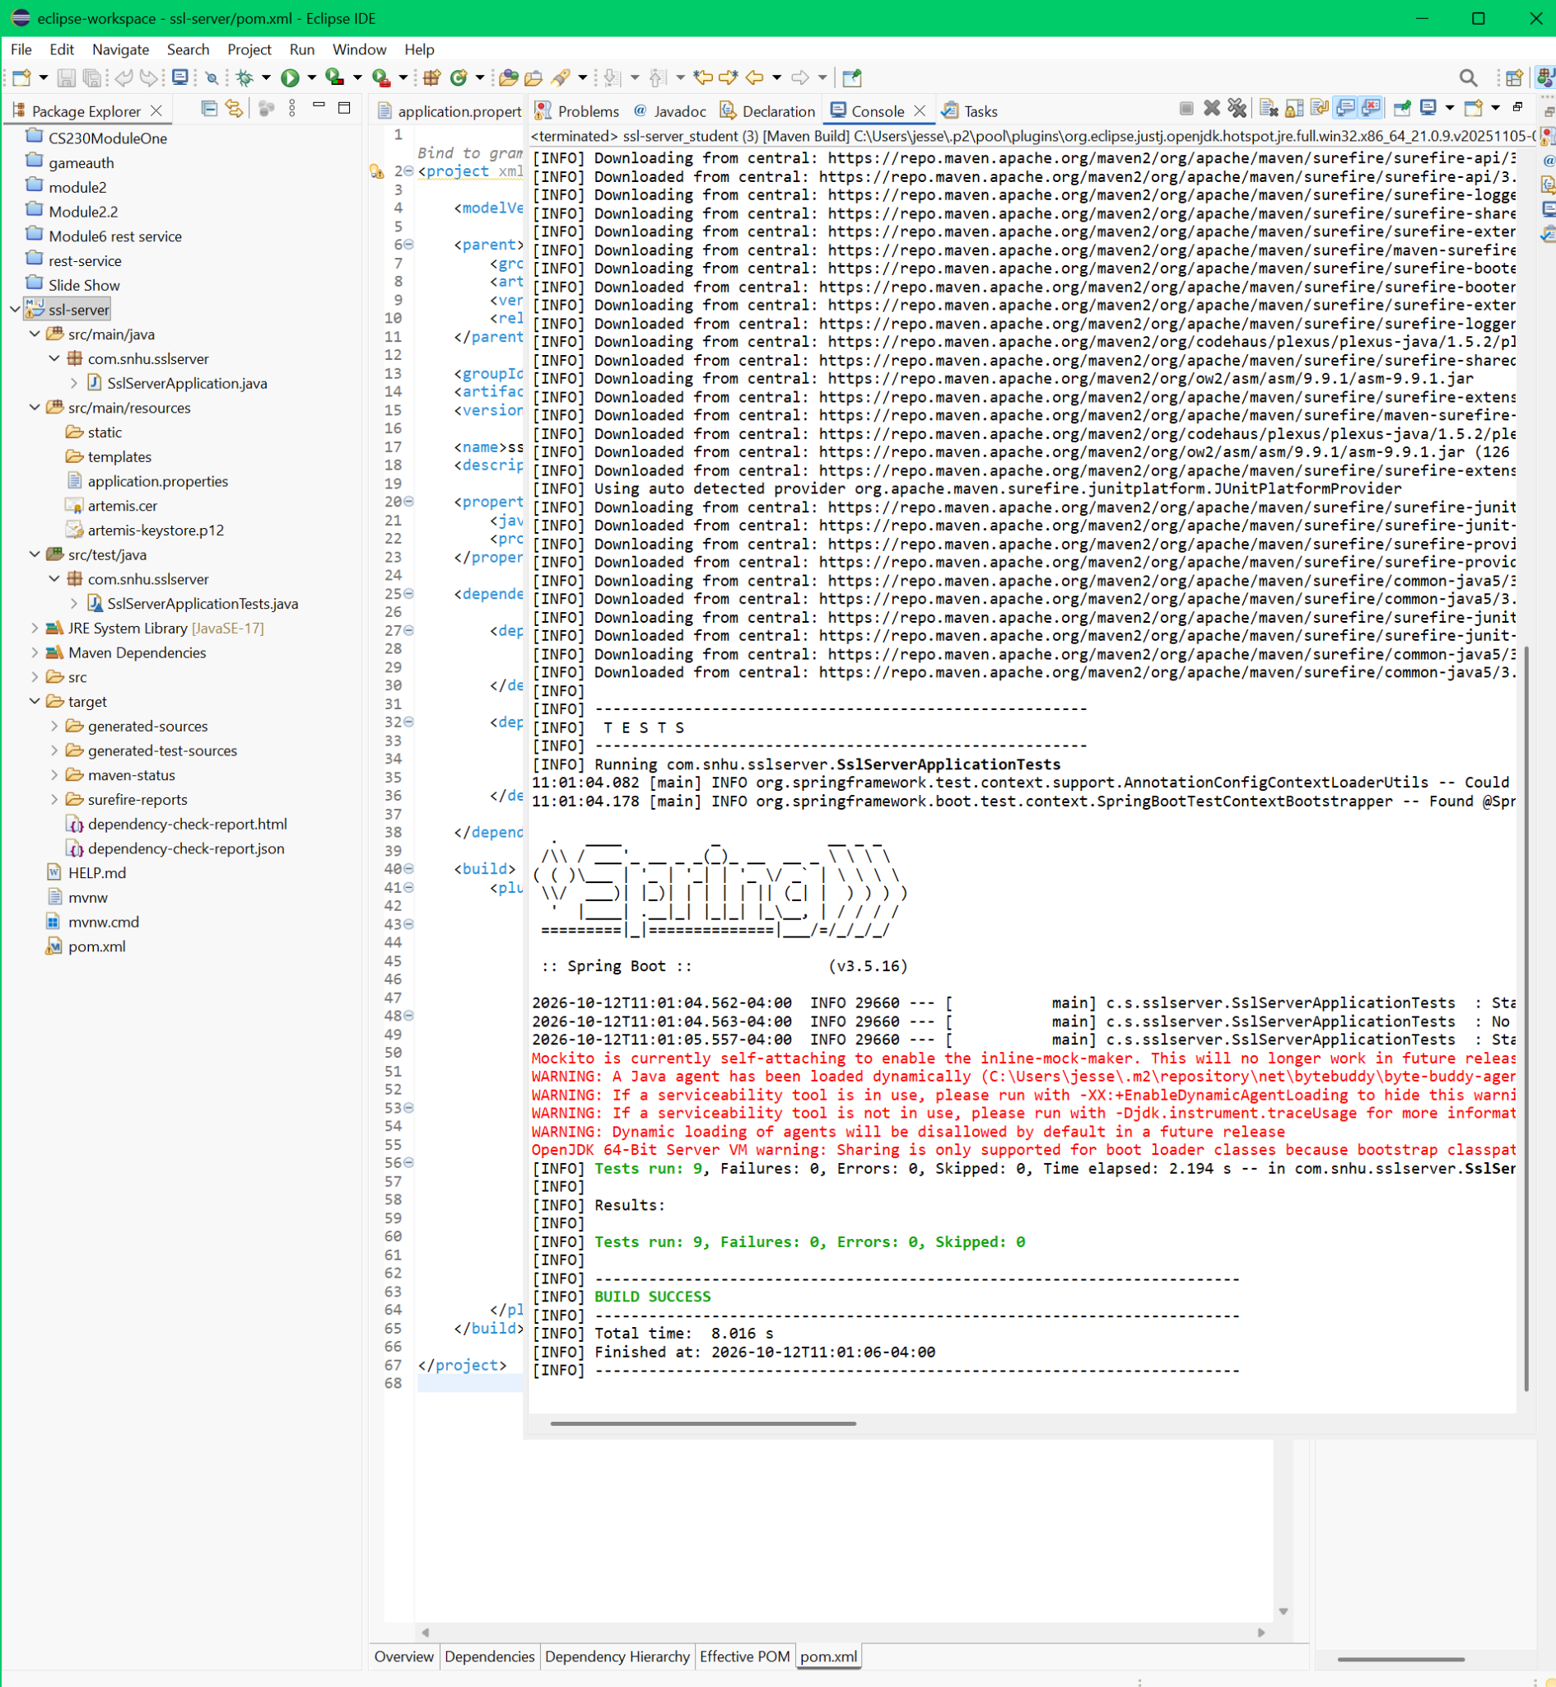

7. Summary
The initial vulnerable design lacked demonstrated secure transport and a file/data checksum verification mechanism. I strengthened the supplied server by adding SHA-256 digest generation and validation, a unique evidence string, reject-on-mismatch behavior, HTTPS with a Java-generated key pair, and repeatable automated tests. In terms of the SNHU vulnerability assessment process, I addressed architecture/configuration (HTTPS boundaries and keystore), cryptography (SHA-256 and TLS), API/controller behavior (/hash and /hash/verify), input validation (null, digest format, and request-size guard), code quality (unit tests), and third-party plug-ins/dependencies (OWASP scan and a Spring Boot update).
The layered approach is important: TLS helps protect data in transit, hashing can reveal changes to data when checked against a trustworthy expected value, validation reduces malformed requests, and dependency scanning helps identify upstream library risks. Retesting after the Spring Boot upgrade confirmed that the checksum tests still passed and that the reported dependency findings fell from 143 to 61, although five dependencies remained flagged. I would not deploy this educational prototype publicly without CA-trusted certificates, authentication/authorization, appropriate integrity authentication, secrets management, vulnerability remediation and operational monitoring.

8. Industry Standard Best Practices
I used standard Java cryptographic APIs instead of implementing custom hashing; explicitly encoded strings as UTF-8; checked input shape before decoding a digest; used MessageDigest.isEqual for digest-byte comparison; kept SSL credentials outside the source configuration; limited the demonstration server to 127.0.0.1; used Maven-managed dependencies; and tested behavior with both passing and failing inputs. OWASP Dependency-Check provided a reproducible software composition analysis, while the dependency upgrade and follow-up scan demonstrated remediation and verification rather than relying on assumptions.
For Artemis Financial, secure software practices reduce the chance of disclosure, tampering, service interruptions, regulatory exposure, and loss of client confidence. Repeatable tests and vulnerability reports also support maintainability and responsible change management. The remaining dependency findings should be tracked and prioritized according to actual application exposure and vendor advisory details, not suppressed solely to improve a score. Before production use, additional controls would include trusted certificate lifecycle management, access control, key rotation, log review, CI-based scans, and approved patch schedules.

